**This Document.**

With the goal of "Instrumentation for Every Student" in mind this project is intended to lower all barriers to providing a hardware and software platform for teaching electronic circuits to engineering students. Every student should have access to affordable hardware and software to measure their experiments.

This project offers a free open source software user interface that is compatible with hardware produced in large quantities at low cost (ranging from $5 to $20) from multiple suppliers.

This document lists various hardware options for very low cost personal instrumentation. These are listed in order by cost / ease of implementation / solderless breadboard friendliness.

**Summary:**

There are some basic assumptions.

First is that the hardware is part of the Arduino ecosystem and the embedded firmware is developed using the Arduino IDE.

Most all hardware platforms in the Arduino world have built in ADCs of some speed / resolution so any / all can provide a basic analog input “oscilloscope” type instrument. They also generally provide at least one fixed DC power supply voltage available for the user. Digital inputs and outputs are available with one or more that can be programed as square wave PWM outputs.

Very few if any have internal DAC analog output(s) that could provide an analog waveform generator output (AWG) function. External components, such as serial (SPI) DAC integrated circuits, generally need to be added to generate analog waveforms. These add-on external circuits (modules) add cost and wiring complexity up to and including mounting everything on a carrier PCB which adds labor and cost.

As an alternate, but less desirable solution, analog outputs can be generated by modulating and low pass filtering one or more digital PWM outputs. The added cost could be as little as a passive resistor and capacitor but the output will not be buffered. A buffer op-amp or active filter circuit could be added.

The options presented here provide some solutions that provide various levels of cost, performance and complexity.

**Versions based on ATSAMD21Boards**

Performance Specs:

* Up to 3 12 bit Scope channels, 100 KSPS for one channel, 55.5 KSPS per channel for two channels or 40 KSPS for all three channels. (Some use cases may require an external input buffer amplifier)
* One 10 bit AWG channel at 70 KSPS (14 uSec)
* Up to 6 digital input channels at same sample rate as analog scope
* 1 PWM digital output or 1 PWM “analog” AWG output

Cost: XIAO at $ 5.40 (plus import Tariff) , QT-Py at $7.50

Seeed Studio XIAO SAMD21 and Adafruit QT-Py SAMD21:

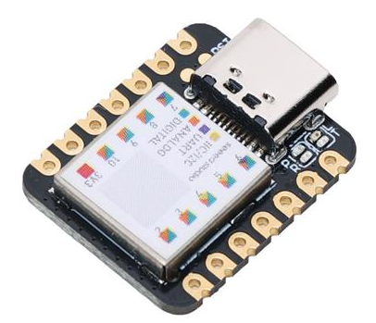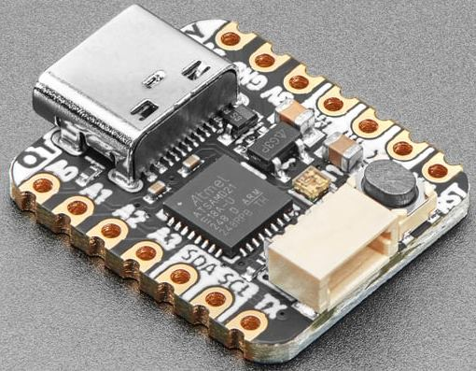

Many experiment setups can be done with just the one 14 pin module. With installed male pin headers, it can be easily inserted into a solderless breadboard and effectively becomes just another “part” in the experimental setup.

Other ATSAMD21 options from Adafruit are the Trinket M0 and ItsyBitsy M0 Express. Also the SparkFun SAMD21 Mini Breakout.

Solderless Breadboard Layout:

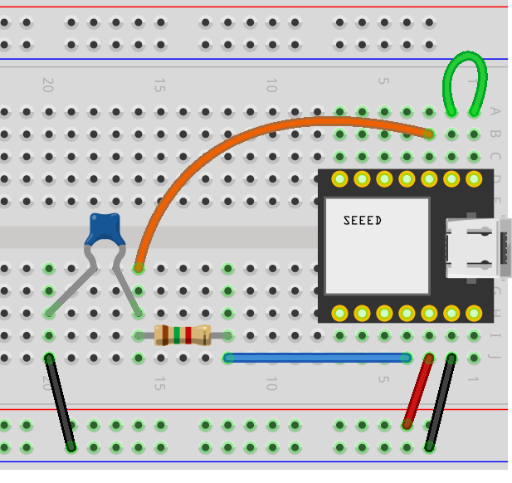

Includes RC low pass filter on PWM AWG output.

**Versions based on ATSAMD51Boards**

Performance Specs:

* Up to 3 12 bit Scope channels at up to 125 KSPS for one channel, 75 KSPS for 2 channels, 50 KSPS for three channels. (Some use cases may require an external input buffer amplifier)
* Two 12 bit AWG channels at 100 KSPS.
* Up to 4 digital input channels at same sample rate as analog scope.

Processor has two built in 12 bit DACs available on pins A0 and A1 so no external AWG circuitry is needed.

Adafruit Itsybitsy M4 Express $ 14.95

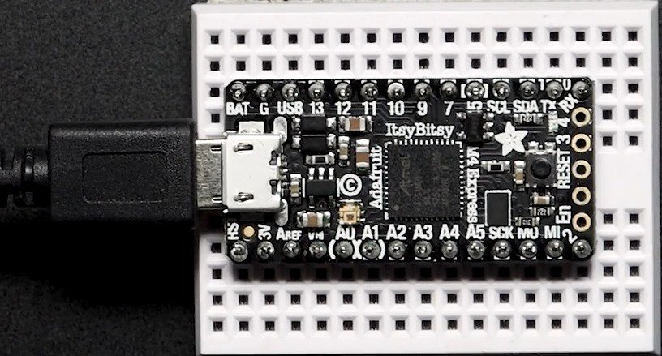

SparkFun Thing Plus - SAMD51 DEV-14713 $21.50

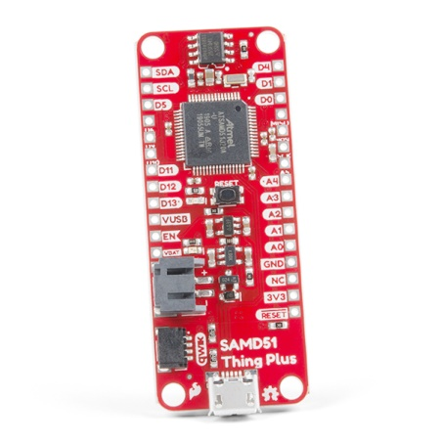

**Versions based on RP2040 + SPI DAC**

Performance Specs:

* Up to 3 12 bit Scope channels at up to 200 KSPS for one channel, 125 KSPS for 2 channels, 83.333 KSPS for three channels. (Some use cases may require an external input buffer amplifier)
* Up to two 8/10/12 bit AWG channels at 50 KSPS.
* Up to 4 digital input channels at same sample rate as analog scope.

Cost: Total, $ 9.13 (plus import Tariff)

Seeed Studio XIAO RP2040:

* Price: Unit Price: $5.40 (plus import Tariff)
* Digi-Key Part Number: 1597-102010428-ND
* Manufacturer: Seeed Technology Co., Ltd
* Manufacturer Product Number: 102010428
* Description: SEEED STUDIO XIAO RP2040 ARDUINO

Dual DAC for AWG outputs: MCP4922-E/P

* Unit Price: $3.73
* Digi-Key Part Number, MCP4922-E/P-ND
* Manufacturer: Microchip Technology
* Manufacturer Product Number: MCP4922-E/P
* Description: IC DAC 12BIT V-OUT 14DIP

Alternate Dual DAC for AWG outputs: MCP4822-E/P

* Unit Price: $4.28
* Digi-Key Part Number, MCP4822-E/P-ND
* Manufacturer :Microchip Technology
* Manufacturer Product Number: MCP4822-E/P
* Description: IC DAC 12BIT V-OUT 8DIP

Alternate 10 and 8 bit dual DACs:

* MCP4812-E/P, $3.01
* MCP4802-E/P, $2.11
* LTC1661CN8, $5.43, 10BIT V-OUT 8DIP
* AD7303BNZ, $11.24, 8BIT V-OUT 8DIP

Again only the two components and some wires are used in this scheme so even more solderless breadboard friendly with the 14 pin XIAO module vs the 40 pin Pi Pico Module. Other RP-2040 based boards are the Adafruit QT Py RP2040 and Adafruit ItsyBitsy RP2040.

Solderless Breadboard Layout including two DAC reconstruction low pass filters.

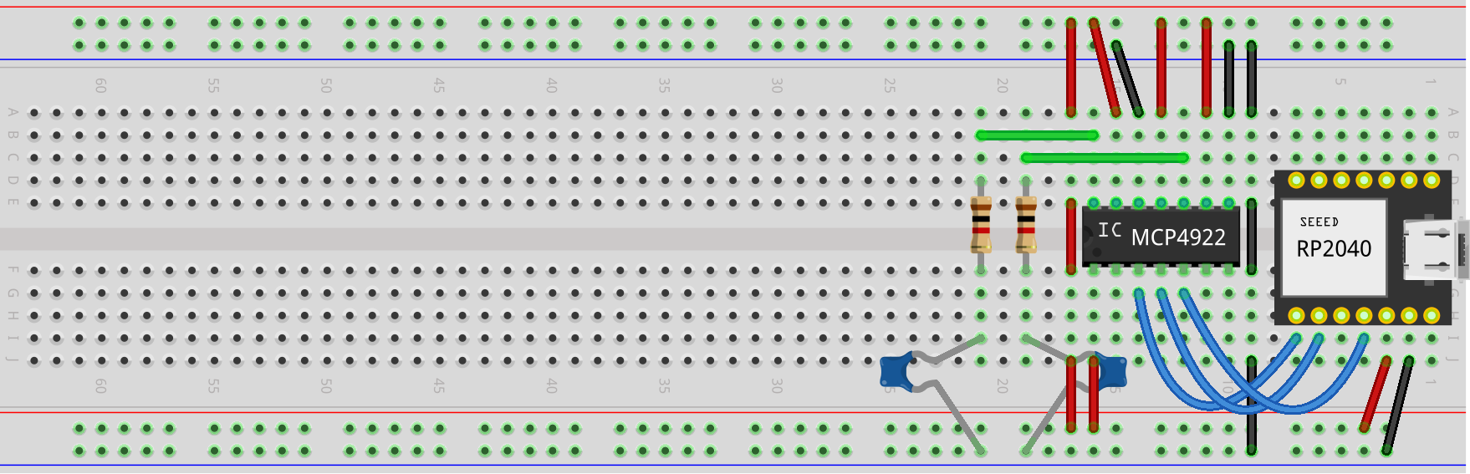

For relative size comparison.

The XIAO module along with SPI DAC could additionally be permanently mounted on a solder breadboard such as this one from Digi-Key: Cost $1.48 + sockets and pin headers.

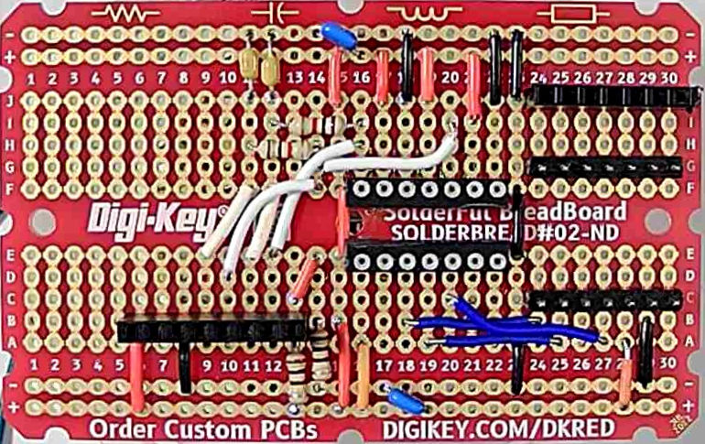

Solder breadboard wiring without active components installed

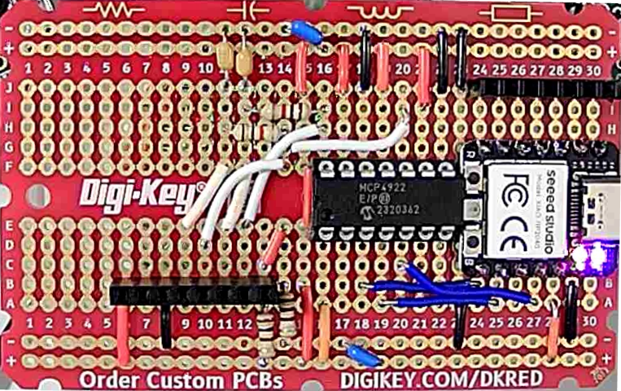

Solder breadboard wiring with active components installed

Digi-Key part number: DKS-SOLDERBREAD-02, 30 ROW SOLDERFUL BREADBOARD

Breadboard, General Purpose Plated Through Hole (PTH) 5 Hole Pad (Both Sides) 0.100" (2.54mm)

**Version based on Raspberry Pi Pico + SPI DAC**

Performance Specs:

* Up to 3 12 bit Scope channels at up to 200 KSPS for one channel, 125 KSPS for 2 channels, 83.333 KSPS for three channels. (Some use cases may require an external input buffer amplifier)
* Up to two 8/10/12 bit AWG channels at 50 KSPS.
* Up to 8 digital input channels at same sample rate as analog scope.
* 1 PWM digital output.

Cost: Total, $ 8.73 (plus import Tariff)

Raspberry Pi Pico RP2040 with headers:

* Unit price: $5.00 ($4.00 w/o headers)
* Digi-Key Part Number: 2648-SC0917-ND
* Manufacturer: Raspberry Pi, Manufacturer Product Number SC0917
* Description :RASPBERRY PI PICO H RP2040 Detailed Description :RP2040 Raspberry Pi Pico - ARM® Cortex®-M0+ MCU 32-Bit Embedded Evaluation Board

Dual DAC for AWG outputs: MCP4922-E/P

* Unit Price: $3.73
* Digi-Key Part Number, MCP4922-E/P-ND
* Manufacturer :Microchip Technology
* Manufacturer Product Number: MCP4922-E/P
* Description: IC DAC 12BIT V-OUT 14DIP

Alternate Dual DAC for AWG outputs: MCP4822-E/P

* Unit Price: $4.28
* Digi-Key Part Number, MCP4822-E/P-ND
* Manufacturer :Microchip Technology
* Manufacturer Product Number: MCP4822-E/P
* Description: IC DAC 12BIT V-OUT 8DIP

Alternate 10 and 8 bit dual DACs:

* MCP4912, MCP4812-E/P, $3.01
* MCP4902, MCP4802-E/P, $2.11
* LTC1661CN8, $5.43, 10BIT V-OUT 8DIP
* AD7303BNZ, $11.24, 8BIT V-OUT 8DIP

Only the two components and some wires are used in this scheme so somewhat solderless breadboard friendly.

Solderless breadboard layout (minus DAC reconstruction filter):

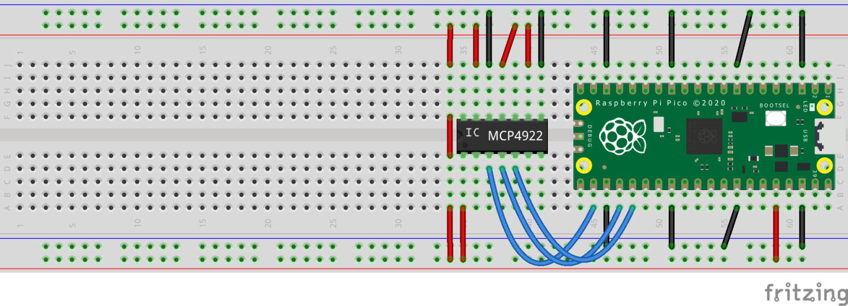

For relative size comparison. About ½ of a full length breadboard is needed.

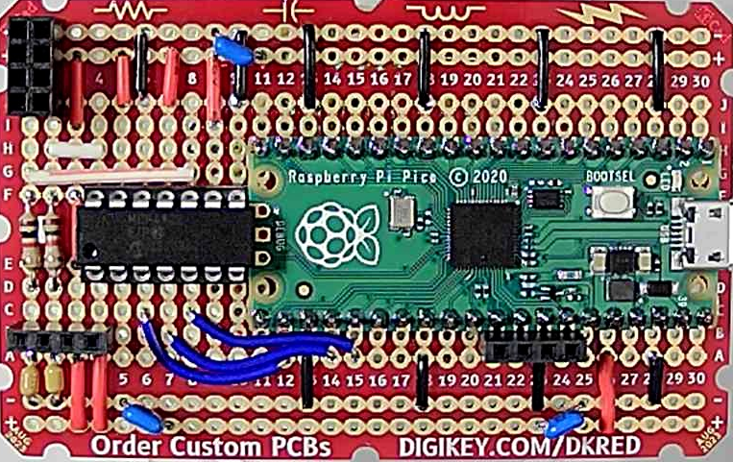

Solder breadboard wiring with active components installed

**Version based on Raspberry Pi Pico + Resistor Networks**

Performance Specs:

* Up to 3 12 bit Scope channels at up to 200 KSPS for one channel, 125 KSPS for 2 channels, 83.333 KSPS for three channels. (Some use cases may require an external input buffer amplifier)
* Up to two 8 bit AWG channels at 100 KSPS
* Up 6 digital input channels at same sample rate as analog scope
* 1 PWM digital output

List of Hardware:

Total parts cost less than $10 not including any PCB to mount parts on or a full length solderless breadboard.

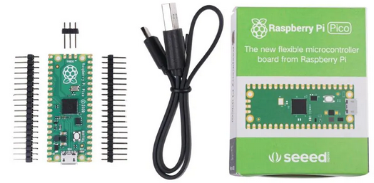

Pi Pico Board Basic Kit $6.38 each or $4.00 for just board no headers or $5.00 with installed headers: (SC0915 Description RASPBERRY PI PICO RP2040)

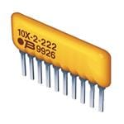

2X - 10 K R/2R ladder network for AWG DACs $ 0.51 each (4606X-R2R-103LF) at Mouser $0.71 at Digi-Key

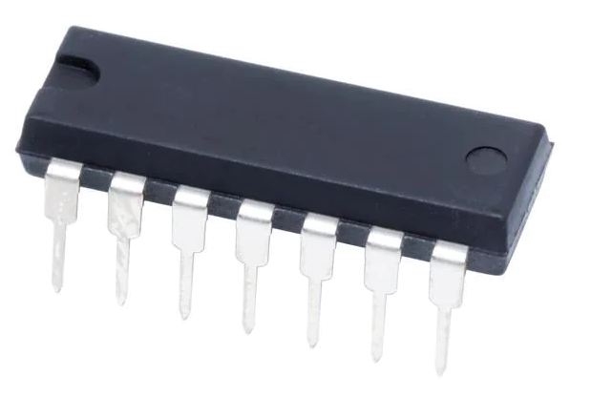

2X - LM324 Quad Op-amp for AWG DAC buffers / Scope Input buffers $0.59 each at Mouser $0.44 at Digi-Key

Needing multiple components is not particularly solderless breadboard friendly so a PCB to mount everything will be a useful approach.

**Option 1a, Solderable Proto Boards:**

This Adafruit PiCowbell Proto for Pico (5200 $1.95) board has a small solderable proto area in the middle which is just large enough for the 2 R/2R SIP resistor networks. The idea behind this proto board is to use stackable headers (5582 $1.50) so that the Pi Pico can be stacked on top while the proto board is plugged into a solderless breadboard.

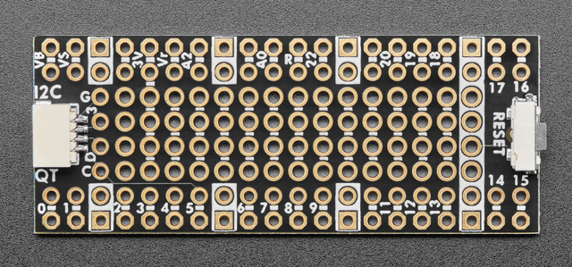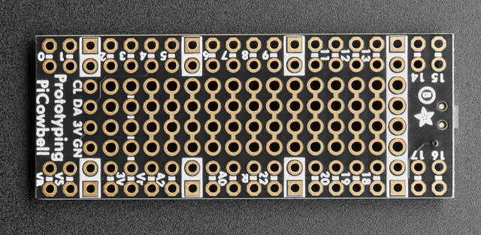

Board Top

Board Bottom

Cut Here

Cut Here

The columns of four holes in the center are shorted together on the bottom layer and need to be cut along the red cut line as indicated to make isolated pairs of pins. The third column from the left on the top is a 3.3V buss and can be used as well when cut into two pairs of holes as indicated by the red cut lines.

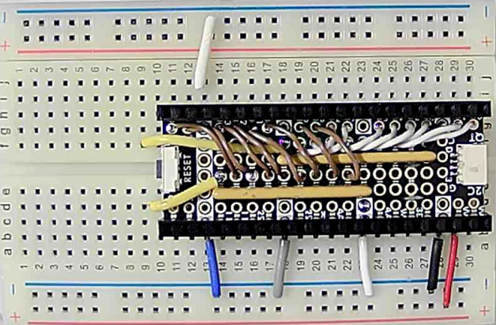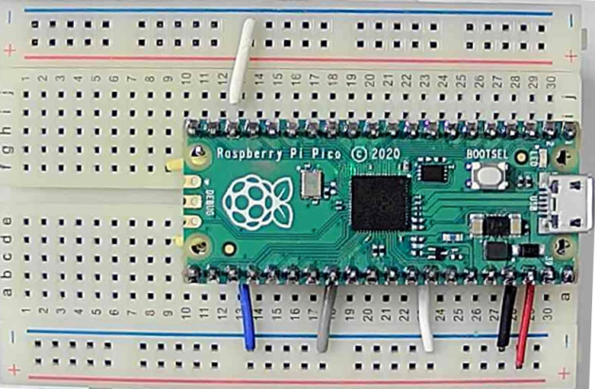

Wired Board with stackable headers

Board with Pi Pico inserted

Wired R2R DAC Proto Board

Insert the two 10 pin resistor ladder networks with the pin 1 black indicator dot to the left. Wire R/2R network to pico digital outputs with jumpers as shown. The two R2R ladder outputs come out the end on jumper wires and can be inserted in the breadboard.

**Option 1b, Solderable Breadboard Boards:**

This solderable breadboard from Digi-Key (1618-DKS-SOLDERBREAD-02-ND - $1.48) has a grid of multiple columns of five holes shorted together on the top and bottom layers of the board. In order to connect the resistor ladder SIP components 20 of the columns need to be cut into sets of 2 shorted pins (I and J) and 3 shorted pins (F-G-H) as shown by the black cut line. This leaves the top two holes in columns 1 – 20 shorted to each other but isolated from the bottom three holes which are also still shorted to each other. Use an ohmmeter to check that all the holes are indeed isolated after you make the cut.

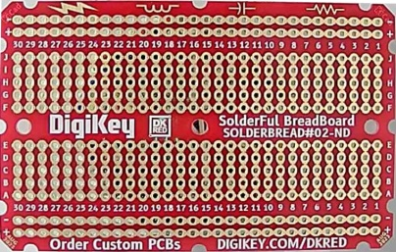

Cut Here

On Top and

Bottom

Layers

Insert the two 10 pin resistor ladder networks in row J (1-10) and row J (11-20) with the pin 1 black indicator dot to the left. The Pi Pico board goes in rows B and G (1-20) as shown.

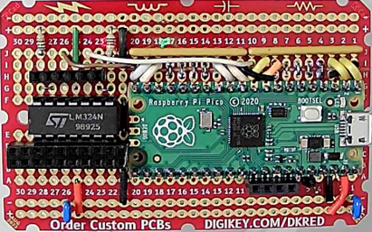

Resistor

Networks

Op-Amp

Buffer

Jumper wires from the pico digital outputs to the ladder network are added. A quad op-amp (LM324) can be fitted in the remaining breadboard area used to buffer the resistor ladder DAC outputs as well. The other two op-amps in the quad package could be used as input buffers for two of the Scope input channels.

**Option 2, Full custom PCB Layout.**

If a full custom PCB is designed then additional circuitry such as op-amp input buffers and DAC output buffers can be included. An example schematic that uses two Quad LM324 op-amps is shown.

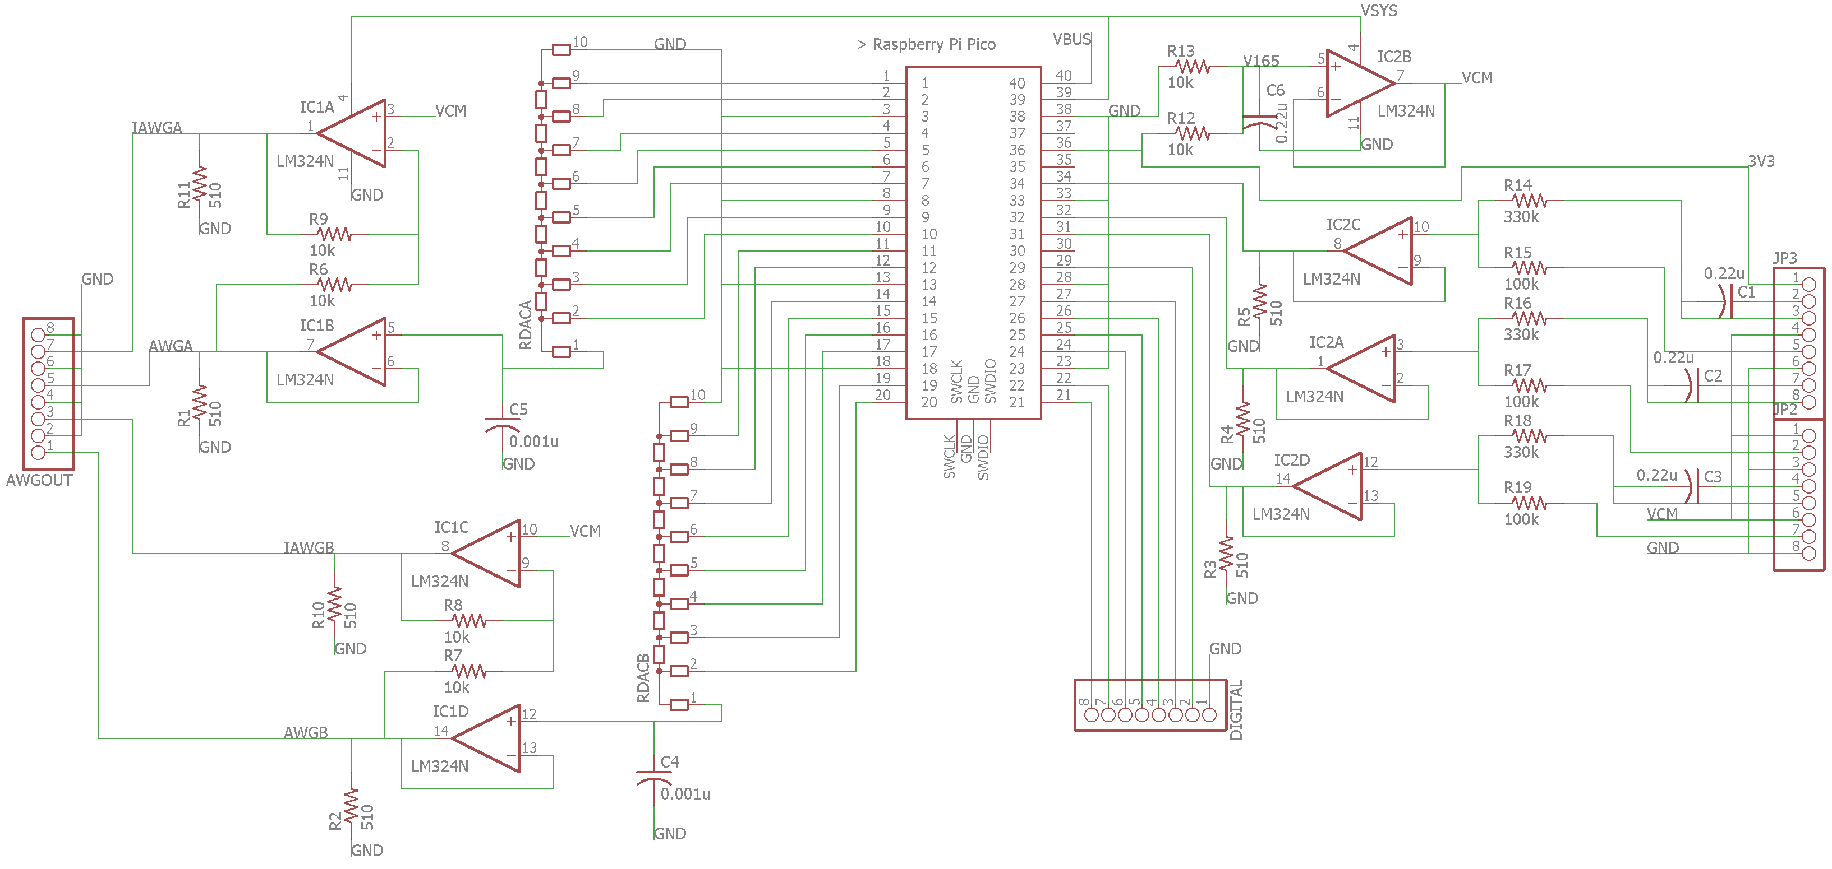

PCB Schematic

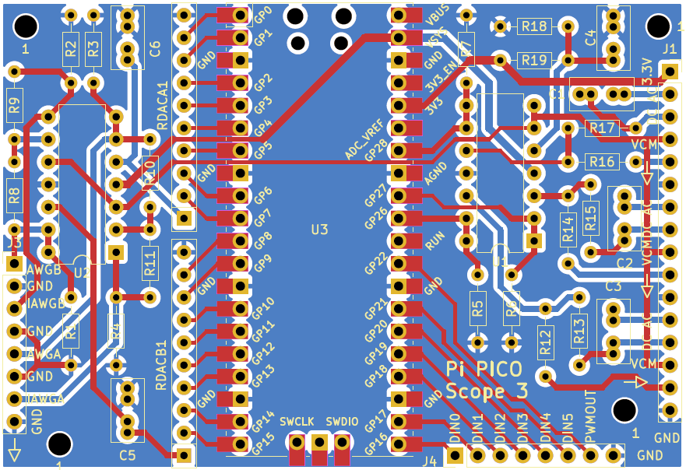

Custom PC Board Layout:

Another Solder breadboard with enough space for R/2R networks and two quad op-amps.

SB4

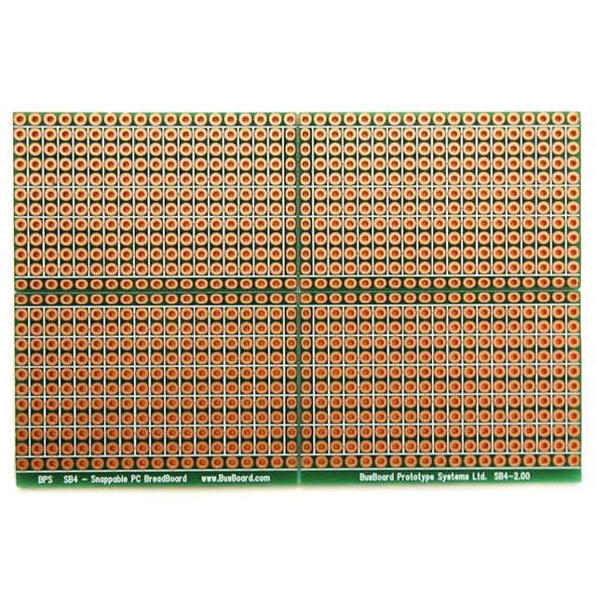

Digi-Key Part Number 4526-SB4-ND - $4.66

Manufacturer BusBoard Prototype Systems

Manufacturer Product Number SB4

Description Breadboard, General Purpose Plated Through Hole (PTH) 2 Hole Pad (Single Side) 0.1" (2.54mm) Grid

**SparkFun ATSAMD21 boards:**

SparkFun RedBoard Turbo - SAMD21 Development Board, DEV-14812 $19.95

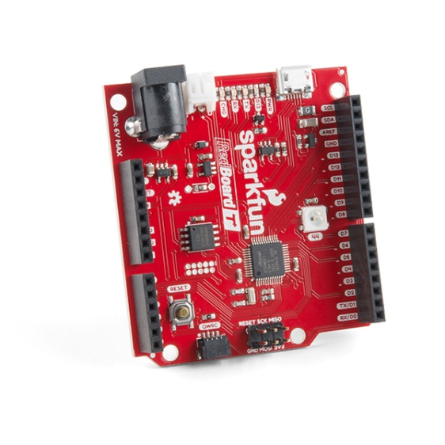

SparkFun SAMD21 Mini Breakout, DEV-13664 $22.50

